Database System Engineering and Distributed Backend Development
Course Code: 25CS1302E
Week-2
Name: V . Charishma
Roll no: 252003140
Query-1:
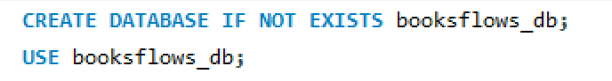
Output:
Query-2:
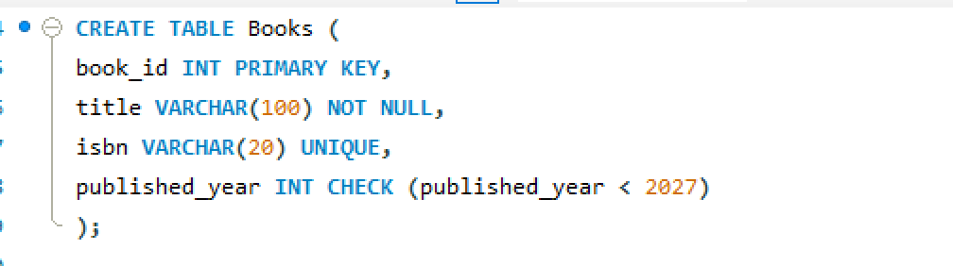
Output:
Query 3:
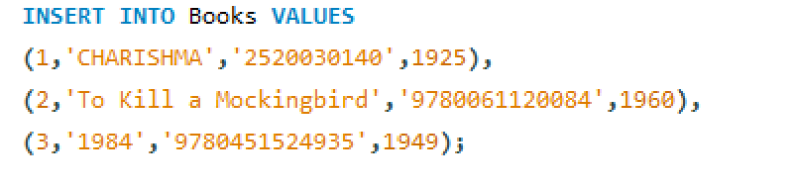
Output:
Query 4

Output:
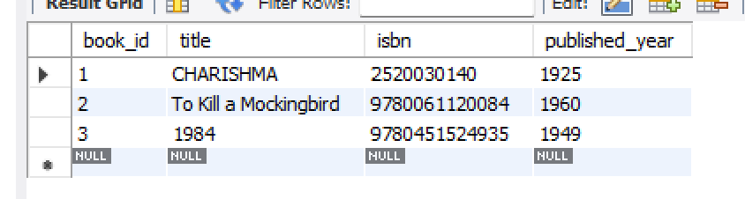
Query 5
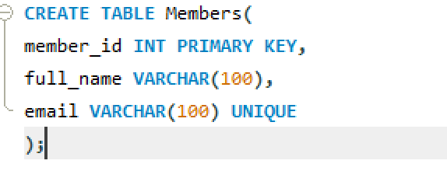
Output:
Query 6
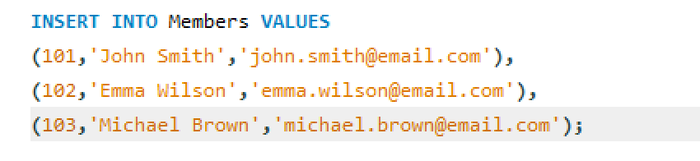
Output:
Query 7

Output:
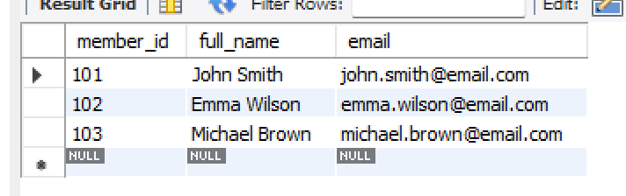
Query 8
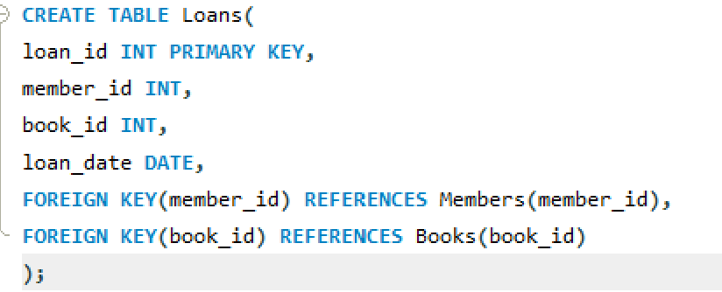
Output:
Query 9
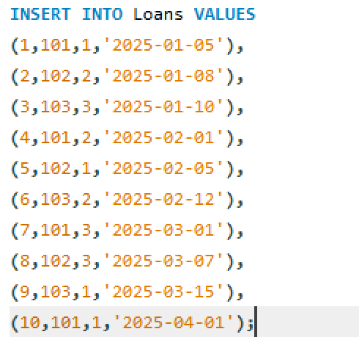
Output:
Query 10

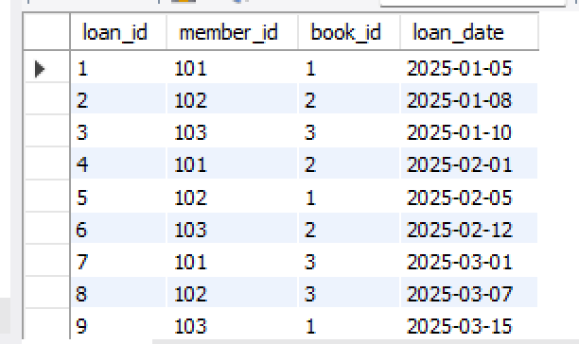
Query 11:
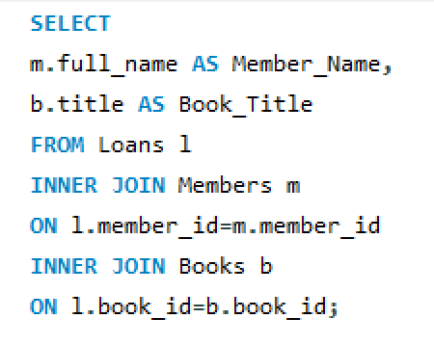
Output:
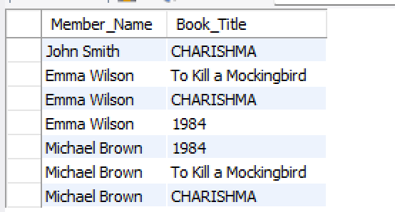
Query 12:
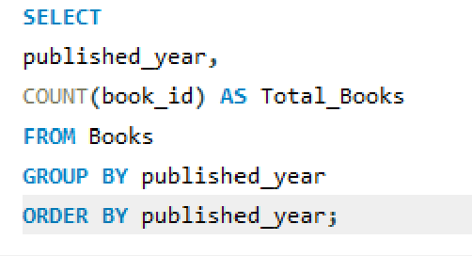
Output:
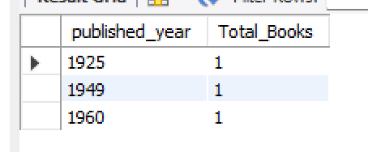
Query 13:
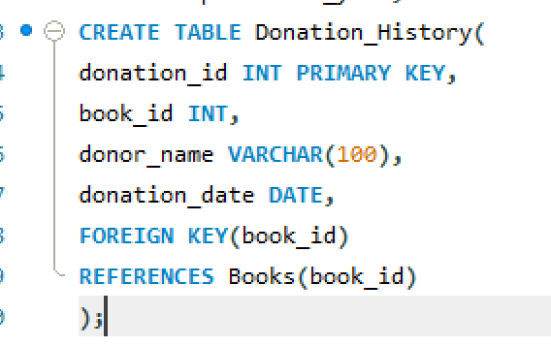
Output:
Query 14:
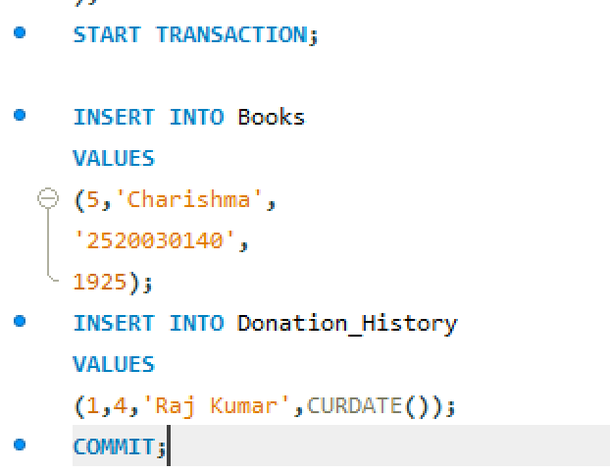
Output:
Query 15:
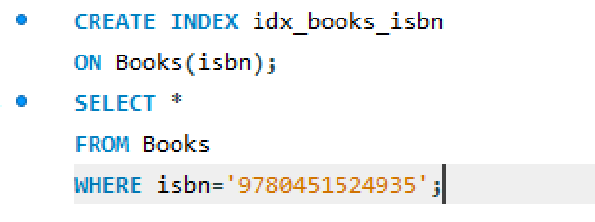

Output:
